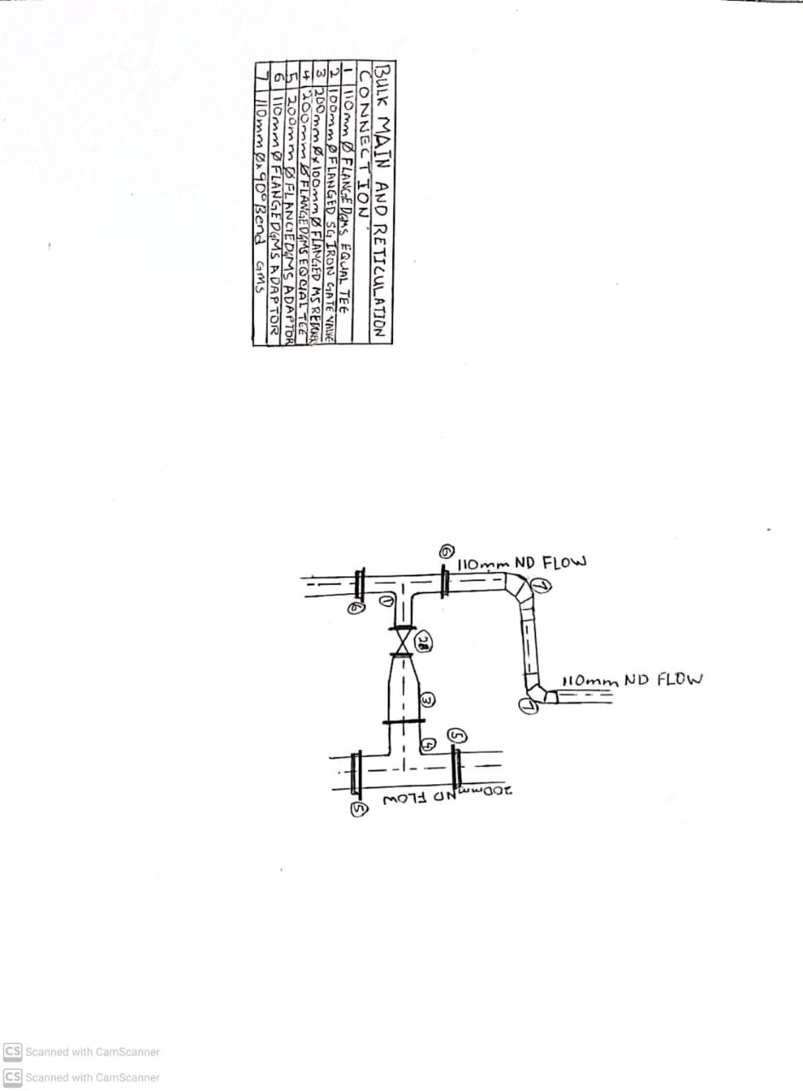

Figure :CONNECTION SKETCH

Table :CONNECTION DETAILS

| **Item** | **Item Payment number** | | **Description** | **Size** | **Qty** | **Unit** | **Rate (R)** | **Amount (R)** |
| --- | --- | --- | --- | --- | --- | --- | --- | --- |
| 1 | 5.6.57 | | 110mm Ø Flanged GMS Equal Tee | 110mm Ø | 1 | No | 5,538.90 | 5,538.90 |
| 2 | 5.6.19 | | 100mm Ø Flanged SG Iron Gate Valve | 100mm Ø | 1 | No | 4,440.00 | 4,440.00 |
| 3 | 5.6.56 | | 200mm Ø x 100mm Ø Flanged MS Reducer | 200mm x 100mm | 1 | No | 2,664.00 | 2,664.00 |
| 4 | 5.6.15 | | 200mm Ø Flanged GMS Equal Tee | 200mm Ø | 1 | No | 5,538.00 | 5,538.00 |
| 5 | 5.6.12 | | 200mm Ø Flanged GMS Adaptor | 200mm Ø | 2 | No | 999.00 | 1,998.00 |
| 6 | 5.6.20 | | 110mm Ø Flanged GMS Adaptor | 110mm Ø | 2 | No | 721.90 | 1,443.80 |
| 7 | 5.6.64 | | 110mm Ø x 90° Bend | 110mm Ø | 2 | No | 2,886.00 | 5,772.00 |
|  | | **TOTAL:** | | | | | | **R 28,174.60** |